**13th Annual Santa Fe Lady Raider Inshore Slam**

**SPONSORSHIP**

**September 6, 2025**

**Grand Slam - $1,000**

Business Logo on Sponsorship page, Business Logo on Tournament shirt, Personal banner and 4 free angler entries

**Homerun - $500**

Business Logo on Sponsorship page, Business Logo on Tournament shirt, and 3 free angler entries

**Triple - $250**

Business Logo on Sponsorship page, Business Logo on Tournament shirt, and 2 free angler entries

**Double - $150**

Business Logo on Sponsorship page, and 1 free angler entry

**Single - $100**

Business Logo on Sponsorship page

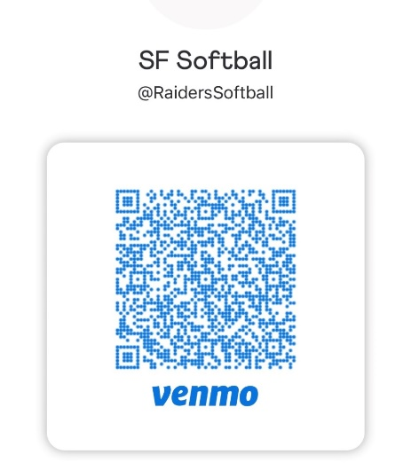

Sponsor Name: __________________________________________________________________________________

Mailing Address: _________________________________________________________________________________

Contact Name: __________________________________________________________________________________

Email & Phone: __________________________________________________________________________________

Lady Raider Player: ______________________________________________________________________________

Authorized Name: (please print) __________________________________________________________________

Authorized Signature: ____________________________________________________________________________

**Call 352-316-3908 for more information…**

**Make all checks payable to:**

**Santa Fe High School Softball Boosters**

**P.O. Box 1651, Alachua, FL 32616**