**13th Annual Santa Fe Lady Raider Inshore Slam**

**September 6th, 2025**

**Sea Hag Marina – Steinhatchee, Florida**

**HEAVIEST LEGAL FISH**

(Red Fish, Trout, Sting Ray and Shark excluded)

1ST Place $75

2nd Place $50

3rd Place $25

**HEAVIEST RED FISH**

1ST Place $500

2nd Place $200

3rd Place $100

**HEAVIEST TROUT**

(Slot fish only 15-19”)

1ST Place $500

2nd Place $200

3rd Place $100

**CALCUTTA**

(Trout over 19” only,

Side pot buy-in)

20$ per Angler

**MOST SPOTS**

**RED FISH**

$200

**JUNIOR ANGLER DIVISION**

(Any legal fish accepted)

1ST Place $75

2nd Place $50

3rd Place $25

*Call 352-316-3908 for more information.*

*Website:* [*www.ladyraiderinshoreslam.com*](http://www.ladyraiderinshoreslam.com)

*Online entry form and tournament information*

**Angler’s Social – Music**

Sea Hag Marina will be hosting the “Angler’s Social” on Friday, September 5th

from 7:00 pm to 9:00 pm. Come give your fishing report, true or not, and pick up some

last minute tips. The Tiki bar will be open for business during this event.

**TOURNAMENT ENTRY FORM**

Captain Name (please print): ________________________________________________________

Address: ____________________________________________________________________________

Cell Phone: ___________________________ Email: _______________________________________

Boat Make: ___________________ Model & Length: _____________________________________

Boat Registration: ___________________________________________________________________

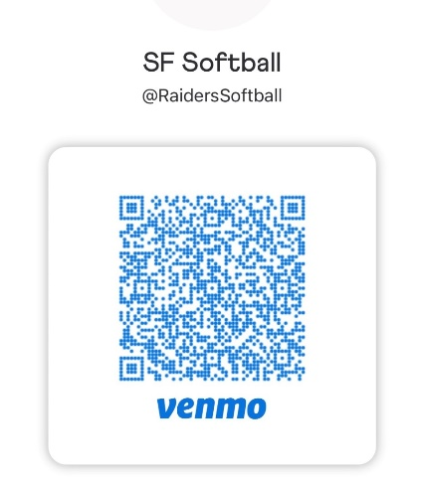

Adults $50 per Angler before August 12th (after that date is $60)

Junior Angler (12 years and younger) $25

***The first 50 paid entries will receive a free tournament shirt***

Name of Anglers Shirt Size

_____________________________________ _____________________

_____________________________________ _____________________

_____________________________________ _____________________

_____________________________________ _____________________

Total number of anglers on boat ________ Total Boat entry fee: $__________________

Lady Raider player to which boat is assigned: _____________________________________

**“MANDATORY” CAPTAIN’S MEETING ON Friday, 9/5/25 at 6:00 pm**

*(One representative from each boat must be present at Sea Hag Marina)*

The following tournament rules will be used and will be interpreted solely by the Tournament Committee and all decisions are final.

1. INDIVIDUAL TOURNAMENT: This is an individual tournament. All prize money will be awarded to one individual.
2. TOURNAMENT COMMITTEE: The committee will consist of Santa Fe High School tournament reps.
3. ELIGIBILITY: All Florida Saltwater Licensed Anglers.
4. HEADQUARTERS/DATE: Sea Hag Marina, 322 Riverside Dr., Steinhatchee, FL 32359 – September 5, 2025
5. ENTRY FEE: $50 per angler before August 12th and the cost goes to $60 after that date. Participants MUST register prior to the start of the tournament.
6. DEPARTURE & END TIME: Safe light until 3pm. Lines in the water 30 minutes before sunrise. No boat checks. Weigh-in will open at 2pm and close at 3pm. Anglers must return by boat and be in line at the stage with poker chip and fish in hand by 3pm.
7. TACKLE & EQUIPMENT: Artificial lures, live bait may be used. Spearfishing or gigging will not be allowed. All fish must be caught on rod and reel.
8. SAFETY & SPORTSMANSHIP: Safe boating and fishing practices must be observed.
9. PERMITTED FISHING LOCATIONS: You must start in Steinhatchee, Florida but you are permitted to travel as far a you would like without touching land during tournament hours.
10. SCORING: All fish must follow FWC regulations. Heaviest Trout - slot fish only 15-19". Calcutta - Trout over 19" only, every angler on the boat must buy in. Pays out 50%. Heaviest Redfish - 18-27". Most Spots - the same redfish you weigh for the heaviest category will count for spots, spots must be separated (not touching, to count as 1). Heaviest Legal Fish - anything legal can be weighed in this category except redfish, trout, sharks, and stingrays. Jr. Angler - anything legal will be accepted other than sharks and stingrays.
11. TIES: In case of a tie, the winner will be the individual that weighed in the earliest.

By signing below, I hereby affirm that I have read and understand all tournament rules and that I will abide by all decisions made by the tournament rules committee. The Tournament Committee, sponsors, or Santa Fe High School are not responsible for accidents or injuries received due to participating in this tournament.

**Captain Signature**: ___________________________________________________________ **Date:** ___________________________________

**Please mail checks to: Santa Fe Softball Boosters, P.O. Box 1651, Alachua, FL 32616**